2008 Leaving Cert Physics Solutions (Ordinary Level)

1.
A student carried out an experiment to find the acceleration of a moving trolley.
The student measured the velocity of the trolley at different times and plotted a graph which was then used to find its acceleration. The table shows the data recorded.

Velocity/ m s⁻¹ | 0.9 | 1.7 | 2.5 | 3.3 | 4.1 | 4.9
Time/s | 0 | 2 | 4 | 6 | 8 | 10

- Describe, with the aid of a diagram, how the student measured the velocity of the trolley.

He took a section of the tape and used the formula velocity = distance/time.
He measured the distance between 11 dots and the time was the time for 10 intervals, where each interval was 1 50th of a second.
- Using the data in the table, draw a graph on graph paper of the trolley’s velocity against time. Put time on the horizontal axis (X-axis).

- Find the slope of your graph and hence determine the acceleration of the trolley.
Take any two points e.g. (0, 0.9) and (10, 4.9) and use the formula
Slope = acceleration = 0.4 m s⁻²

2.
You carried out an experiment to find the speed of sound in air, in which you measured the frequency and the wavelength of a sound wave.
- With the aid of a diagram describe the adjustments you carried out during the experiment.
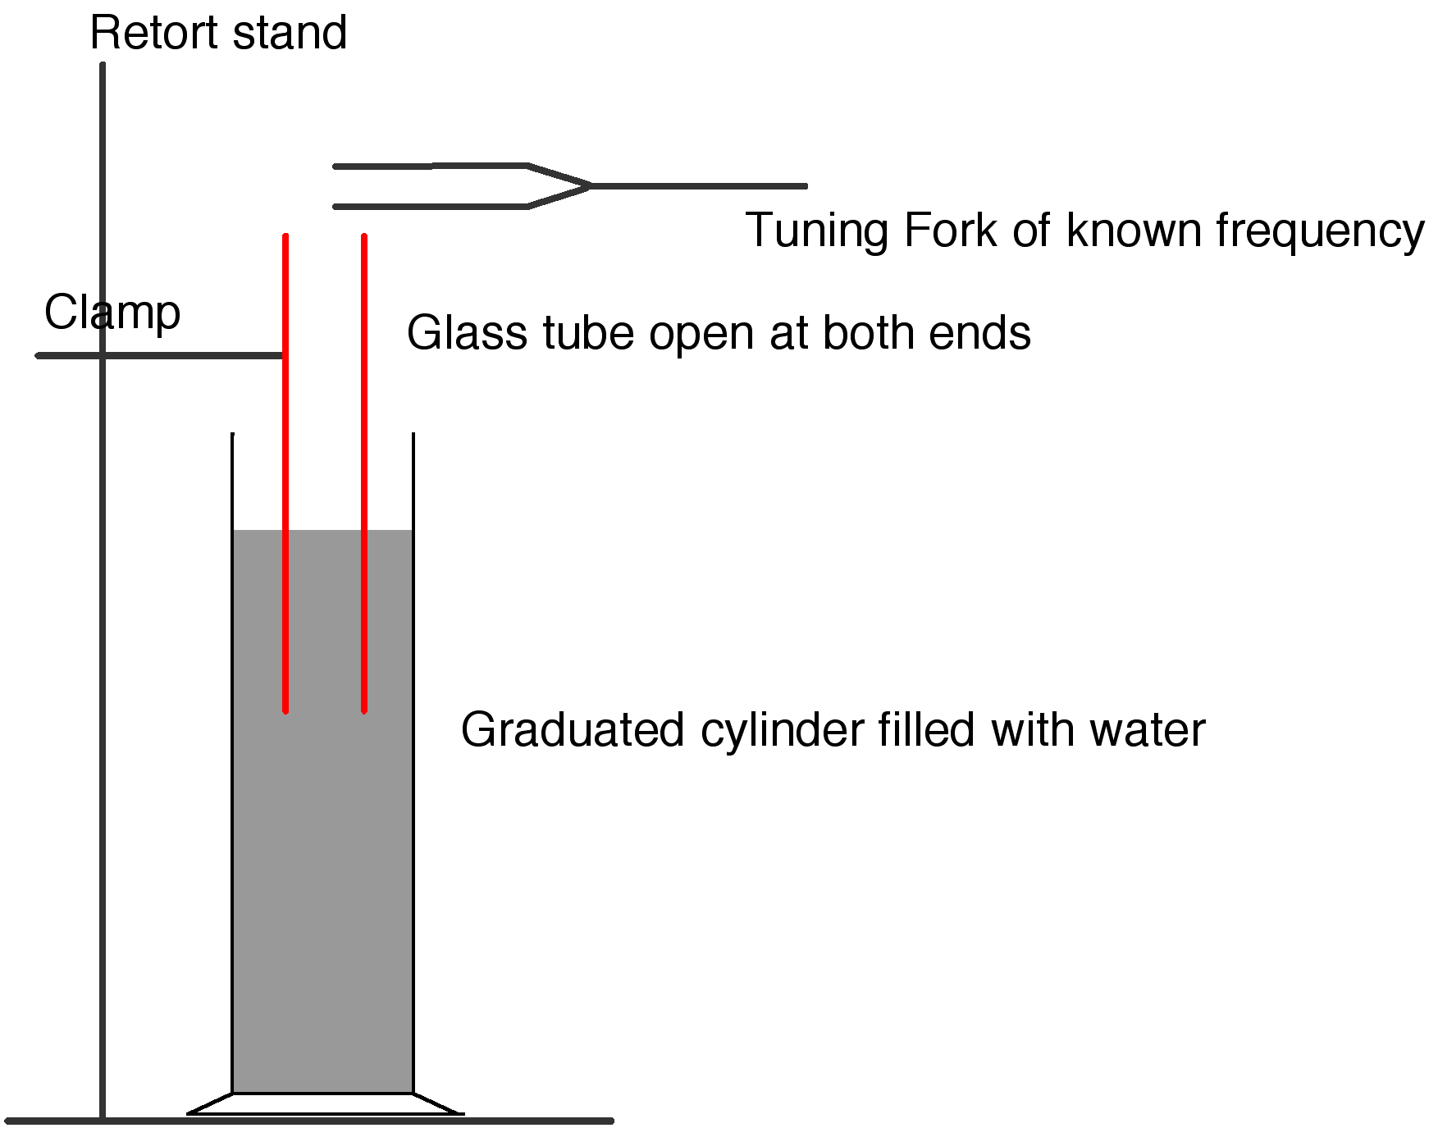
We adjusted the length of the inner tube until resonance occurred.
- How did you find the frequency of the sound wave?
We read it from the tuning fork which was used to create the sound wave.
- How did you measure the wavelength of the sound wave?
We measured the diameter of the inner tube using digital callipers.
We measured the length of the inner tube above the water.
We then used the formula λ = 4(l + 0.3d) to calculate the wavelength.
- How did you calculate the speed of sound in air?
We substituted the values for frequency and wavelength into the formula c = f λ
- Give one precaution you took to get an accurate result.
Repeat using different tuning forks and take an average, clamp tube to take measurements.

3.
An experiment was carried out to measure the refractive index of a substance.
The experiment was repeated a number of times.
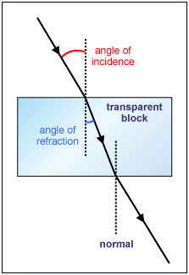
- Draw a labelled diagram of the apparatus that could be used in this experiment.
As in diagram, plus a ray box and protractor.
- What measurements were taken during the experiment?
The angle of incidence and the angle of refraction.
- How was the refractive index of the substance calculated?
By using the formula n = sin i ÷ sin r.
- Why was the experiment repeated?
To increase the accuracy of the results.

4.
The diagram shows a circuit used to investigate the variation of current with potential difference for a semiconductor diode in forward bias.
- Name the apparatus X. What does it measure?
Ammeter. It measures amps.
- Name the apparatus Y. What does it do?
Rheostat / variable resistor / potential divider
It changes the resistance which in turn changes the voltage.
- What is the function of the 330 Ω resistor in this circuit?
It protects the diode by limiting the current.

The table shows the values of the potential difference used and its corresponding current recorded during the experiment.
potential difference/V | 0 | 0.2 | 0.4 | 0.6 | 0.8 | 1.0
current/mA | 0 | 3 | 6 | 14 | 50 | 100

- Using the data in the table, draw a graph on graph paper of the current against the potential difference.
Put potential difference on the horizontal axis (X-axis).
- What does the graph tell you about the variation of current with potential difference for a semiconductor diode?
They are not proportional because the current rises rapidly after the potential difference reaches 0.6 V.
5.
  - State the principle of conservation of momentum.
The principle of conservation of momentum states that in any collision between two objects, the total momentum before impact equals total momentum after impact, provided no external forces act on the system.
  - A solid block in the shape of a cube of length 120 cm rests on a table. The weight of the block is 25 N.
Calculate the pressure it exerts on the table.
P = F/A ⇒ P = 25 ÷ (1.2)² ⇒ P = 17.4 pa
  - Which of the following is the unit of energy? Kelvin watt newton joule
Answer: joule
  - What physical quantity is measured in decibels?
Sound intensity.
  - A concave lens has a power of 0.1 cm⁻¹. What is the focal length of the lens?
10 cm.
  - Give one effect of static electricity?
Lightning, static discharge, receive shock after walking across carpets, attracts objects, can damage electronics.
  - Give two uses for the instrument shown.
It can function as a voltmeter, ammeter, ohmmeter or thermometer.
  - What is the colour of the live wire in an electric cable?
Brown
  - State two properties of X-rays.
Electromagnetic waves, have short wavelength, cause ionisation, penetrate materials, no mass and no charge.
  - What is nuclear fusion?
Nuclear Fusion is the combining of two small nuclei to form one large nucleus with the release of energy.

6.
The weight of an object is due to the gravitational force acting on it.
Newton investigated the factors which affect this force.
- Define force and give the unit of force.
A Force is anything which can cause an object to accelerate.
The unit of force is the newton.
- State Newton’s law of universal gravitation.
Newton’s Law of Gravitation states that any two point masses in the universe attract each other with a force that is directly proportional to the product of their masses, and inversely proportional to the square of the distance between them.
- Calculate the acceleration due to gravity on the moon.
The radius of the moon is 1.7 × 10⁶ m and the mass of the moon is 7 × 10²² kg.

A lunar buggy designed to travel on the surface of the moon had a mass of 2000 kg when built on the earth.
- What is the weight of the buggy on earth?
W = mg = 2000 × 9.8 = 19600 N
- What is the mass of the buggy on the moon?
2000 kg
- What is the weight of the buggy on the moon?
W = mg = 2000 × 1.6 = 3200 N
- A powerful rocket is required to leave the surface of the earth.
A less powerful rocket is required to leave the surface of the moon.
Explain why.
Gravity less on moon so less force is needed to escape.

7.
The temperature of an object is measured using a thermometer, which is based on the variation of its thermometric property.

- What is meant by temperature?
The Temperature of an object is a measure of the hotness or coldness of that object.
- What is the unit of temperature?
The SI unit of temperature is the Kelvin (K)
- Give an example of a thermometric property.
Resistance, length (of column of mercury), emf.

The rise in temperature of an object depends on the amount of heat transferred to it and on its specific heat capacity.
- What is heat?
Heat is a form of energy
- Name three ways in which heat can be transferred.
Conduction, convection, radiation
- Define specific heat capacity.
The Specific Heat Capacity of a substance is the heat energy needed to change one kilogram of the substance by one Kelvin.

A saucepan containing 500 g of water at a temperature of 20 °C is left on a 2 kW ring of an electric cooker until it reaches a temperature of 100 °C.
All the electrical energy supplied is used to heat the water.
- Calculate the rise in temperature of the water.
100 – 20 = 80 °C
- Calculate the energy required to heat the water to 100 °C.
Q = m cΔθ = 0.5 × 4200 × 80 = 168 000 J
- Calculate the amount of energy the ring supplies every second.
2 kW = 2,000 W = 2,000 J per second.
- Calculate the time it will take to heat the water to 100 °C.
P = W/t ⇒ t = W/P ⇒ t = 168 000/2,000 = 84 secs.

8. The diagram shows a signal generator connected to two loudspeakers emitting the same note.
A person walks slowly along the line AB.

- What will the person notice?
The loudness of the sound increases and decreases at regular intervals.
- Why does this effect occur?
Because of interference caused from the two speakers.
- What does this tell us about sound?
Sound is a wave.
- Describe an experiment to demonstrate that sound requires a medium to travel.
- Set up the Bell-Jar – the bell can be heard ringing.
- Remove the air from the Bell-Jar using a vacuum pump.
- Result: While the bell can still be seen to be ringing, the sound gets quieter until eventually nothing can be heard.
- The pitch of a note emitted by the siren of a fast moving ambulance appears to change as it passes a stationary observer. Name this phenomenon.
The Doppler effect.
- Explain how this phenomenon occurs.
As the sound source approaches the wave-fronts become closer together therefore the wavelength becomes shorter and the frequency gets higher.
- Give an application of this phenomenon.
Speed gun, measuring red shift, ultrasonic scanners, radar, used to study heart beat, etc.

9.
An electric current flows in a conductor when there is a potential difference between its ends.
- What is an electric current?
An electric current is a flow of charge.
- Give two effects of an electric current.
Heating, magnetic, chemical.
- Name a source of potential difference.
Battery, generator, thermocouple.
- Describe an experiment to investigate if a substance is a conductor or an insulator.
Apparatus: circuit to show power source, ammeter/ bulb, leads,
Procedure: connect the circuit and place item between contacts
Observation: If the bulb lights then the item is a conductor; if the bulb does not light then the item is an insulator.
- The two headlights of a truck are connected in parallel to a 24 V supply.
Draw a circuit diagram to show how the headlights are connected to the supply.
Circuit diagram showing battery and two bulbs connected in parallel.
- What is the advantage of connecting them in parallel?
If one goes the other still works, they are brighter.
- Why should a fuse be included in such a circuit?
To prevent too high a current flowing.
- The resistance of each headlight is 20 Ω. Calculate the total resistance in the circuit.
For resistors in parallel we use the formula

⇒ R = 10 Ω
- Calculate the current flowing in the circuit.
V = IR ⇒ I = V/R ⇒ I = 24/10 = 2.4 A.

10.
- Give two properties of an electron.
Negatively charged; deflected by electric and magnetic fields; fundamental particle; small mass.
The diagram shows the arrangement used by Rutherford to investigate the structure of the atom. During the investigation he fired alpha-particles at a thin sheet of gold foil in a vacuum.
- What are alpha-particles?
An alpha particle is a helium nucleus (composed of 2 protons and 2 neutrons).
- Describe what happened to the alpha-particles during the experiment.
Most went straight through,some were deflected by various amounts while some bounced back completely.
- What conclusion did Rutherford make about the structure of the atom?
He concluded that it was mostly empty space, with a very dense nucleus.
- How are the electrons arranged in the atom?
They orbit the nucleus.
- Name a device used to detect alpha-particles.
GM tube, solid state detector, cloud chamber, ionisation tube, etc.
- Why was it necessary to carry out this experiment in a vacuum?
The alpha particle would normally be stopped by a few cm of air.

11.
Read this passage and answer the questions below.
Energy is essential to the comfort of our homes. There are many ways of reducing energy needs and meeting those needs with renewable sources. The main sources of renewable energy are the sun (solar energy), the wind, moving water (hydropower, wave and tidal energy), heat below the surface of the earth (geothermal energy) and biomass (wood, waste, crops).
Solar heating systems are used in many homes. These systems have two main parts: a solar panel and a hot water storage cylinder. Typically, a panel is placed on the roof, facing directly south. However, a good output can still be achieved between south-east and south-west.
The sun heats a black metal plate in the panel, which, in turn, heats water in pipes in the panel. To move the heated water between the panel and the storage cylinder, a system either uses a pump or the tendency of water to naturally circulate as it is heated. The solar water heating system needs to be backed up by a conventional heat source.
(Adapted from ‘Renewable energy in the home’ a guide by Sustainable Energy Ireland.)
  - State two uses of energy in the home.
Heating, cooking, lighting, TV etc
  - Give two ways to reduce energy needs in the home.
Insulate, double glaze, reduce usage, use low energy appliances, turn off unused lights, etc.
  - List the main sources of renewable energy.
Solar, wind, wave, tidal, geothermal, biomass
  - What are the main parts of a solar heating system?
Solar panel, hot water storage cylinder.
  - Why does a solar panel need to face south?
To get the most sunlight.
  - What is the function of the backup heater?
For use at night or in poor sunlight.
  - Why are parts of the solar panel painted black?
Black is a good absorber of heat
  - What is the name given to the tendency of water to circulate as it is heated?
Convection

12.
(a)
- Define velocity.
Velocity is the change in displacement with respect to time.
- Define acceleration.
Acceleration is the change in velocity with respect to time
- A speedboat starts from rest and reaches a velocity of 20 m s⁻¹ in 10 seconds.
It continues at this velocity for a further 5 seconds.
The speedboat then comes to a stop in the next 4 seconds.
Draw a velocity-time graph to show the variation of velocity of the boat during its journey.
- Use your graph to estimate the velocity of the speedboat after 6 seconds.
12 m s⁻¹.
- Calculate the acceleration of the boat during the first 10 seconds.
A = v/t = 20/10 = 2 m s⁻².
- What was the distance travelled by the boat when it was moving at a constant velocity?
v = s/t ⇒ s = vt = 20×5 = 100 m

(b)
Sunlight is made up of different colours and invisible radiations.
- How would you show the presence of the different colours in light?
Apparatus: light source, glass prism
Procedure: shine the light through the prism
Observation: light spreads out into different colours
- Name two radiations in sunlight that the eye cannot detect.
Infra-red and ultra-violet
- Describe how to detect one of these radiations.
 | Infra red | Ultra violet
Apparatus | Infra red thermometer | Florescent material
Procedure | Place thermometer just beyond the red end of a spectrum | Place the florescent material just beyond the violet end of the spectrum
Observation | There will be a rise in temperature | The material fluoresces (glows)

- Give a use for this radiation.
- Give a use for one of these invisible radiations.
Infra Red: Source of heat, keep things warm, hatch chickens, heat treatment of muscles etc.
Ultra-violet: detect forged currency, disco lights, used in insect removal device, sterilisation, suntan, forensics.

(c)
- What is the photoelectric effect?
The Photoelectric Effect is the emission of electrons from a metal due to light of a suitable frequency falling upon it.

A photocell is connected to a sensitive galvanometer as shown in the diagram.
When light from the torch falls on the photocell, a current is detected by the galvanometer.
- Name the parts of the photocell labelled A and B.
A = cathode, B = anode
- How can you vary the brightness of the light falling on the photocell?
Move it towards or away from the photocell.
- How does the brightness of the light affect the current?
The brighter the light the greater the current.
- Give a use for a photocell.
Burglar alarms, automatic door, control burners in heating systems, safety switches, light meters, solar cells.

(d)
- What is electromagnetic induction?
Electromagnetic Induction occurs when an emf is induced in a coil due to a changing magnetic flux.
- A magnet and a coil can be used to produce electricity.
How would you demonstrate this?
Apparatus: coil, magnet and galvanometer.
Procedure: Set up as shown.
Move the magnet in and out of the coil.
Observation: the needle deflects.
- The electricity produced is a.c. What is meant by a.c.?
Alternating current

